**CREATIVE DESIGN AND MULTIMEDIA INSTITUTE**

**A Project Report**

**ON**

# **Primera Nuts**

# 



**Academic Year : 2023-24**

**Developed By : ANSH BHALU**

# **I n d e x**

|  |  |  |
| --- | --- | --- |
| **No.** | **Title** | **Page No.** |
| **1.** | **Project Profile**  **Project Description**  **Website objective**  **Website Features** | **2**  **3**  **3-4**  **4** |
| **2.** | **Top selling products** | **5-7** |
| **3.** | **Store Information** | **7-8** |
| **4.** | **Website Pages** | **9-17** |
| **5.** | **Future Update** | **18** |

|  |  |
| --- | --- |
| **Project Name:** | PRIMERA NUTS |
| **Technology:** | WEB |
| **Guide By** | JAYDEEP SIR |
| **Submitted To:** | CREATIVE DESIGN AND MULTIMEDIA INSTITUTE0 |
| **Developed By:** | ANSH BHALU |

**CREATIVE DESIGN AND MULTIMEDIA INSTITUTE**

# **Project profile**

Project Description

**Website Tital: Primera Nuts**

**Platform: PC ,Mobail**

**Target Audience**: **All the users**

Provide a brief introduction to your website, its mission, and what customers can expect.

**Example:** Welcome to PRIMERA NUTS we offer a wide range of premium-quality dry fruits at competitive prices. Whether you're looking for healthy snacks or ingredients for your recipes, we have everything you need. Enjoy great discounts and explore our top-selling products for the best value!

### **Website Objective**:

The objective of Primera dry fruit website is to create a seamless online platform that offers high-quality dry fruits and nuts to health-conscious customers, catering to their dietary needs, gifting requirements, and everyday snacking preferences.

Website Features

1. **Wide Selection of Dry Fruits**

* Almonds, cashews, pistachios, walnuts, raisins, dates, figs, and more.
* Organic and premium options available.

2. **Seasonal Offers and Discounts**

* Ongoing discounts on bulk purchases.
* Special festive discounts and promotions.

3. **Top-Selling Products**

* Highlighted items with the highest customer satisfaction and demand.

Product Categories

1. Almonds: High in protein and antioxidants.

2. Cashews: Creamy and rich in minerals like magnesium.

3. Pistachios: A great source of fiber and heart-friendly fats.

Top-Selling Products

**2. Rose Almond**

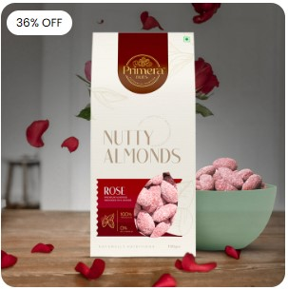

**1. Sleek Chocolate Almonds**

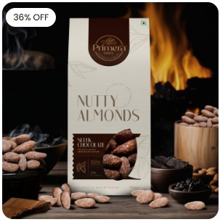

**4. Salted and Rosted Almonds**

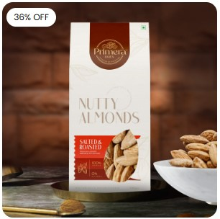

**3. Plain Almond**

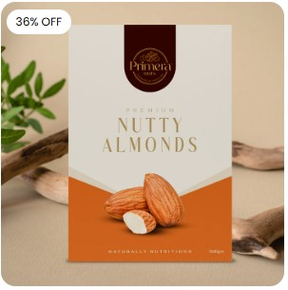

**5. Jalapeno Almonds**

0

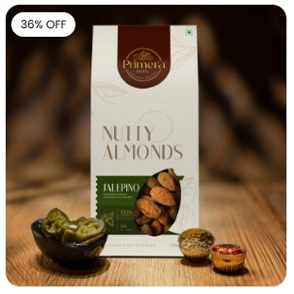

**6. Blueberry Almonds**



Gift Product Categories :-

**Primera Gift Box - 6 Pack**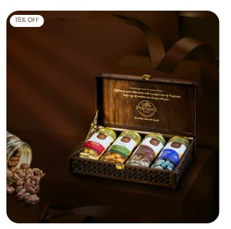

**Primera Gift Box-4 Pack**

### 

**Primera Gift Box - 8 Pack**

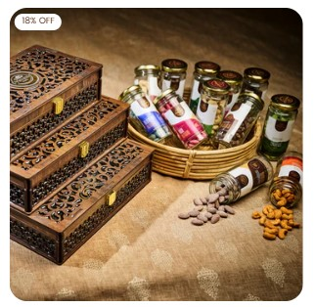

**Welcome the Primera Nut Haven!**

Looking for a healthy boost of energy during your day? Welcome to PRIMERA NUTS, where nuts are more than just snacks—they're a way of life! Packed with protein, fiber, and essential nutrients, they'll keep you fueled and satisfied, whether you're hitting the gym or powering through a busy workday.



From classic favorites like almonds and cashews to exotic finds like raisins and seeds our shelves are stocked with a tantalizing nuts. Each nut in our store is carefully selected to ensure freshness, flavor, and nutrition, so you can snack with confidence.

So come on in, grab a scoop, and indulge in the nutty goodness that awaits you at Primera Nuts. Step into our nut haven and experience a world of crunchy delights.

**Satisfy Cravings :-**

Your hub for tasty, healthy snacks and thoughtful corporate gifts!

**Website Pages**

**1. Home Page :-**

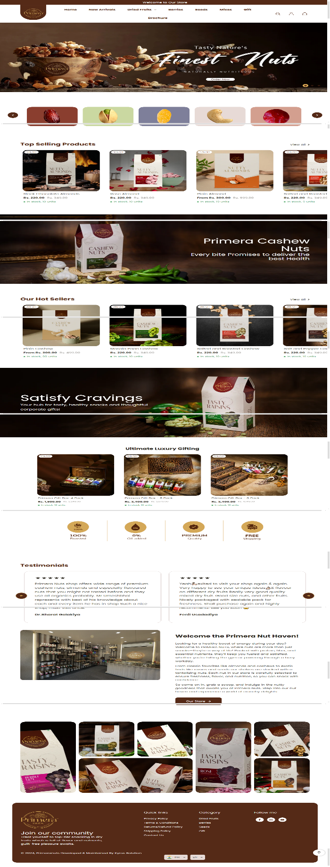

**2.** New Arrivals **Page :-**

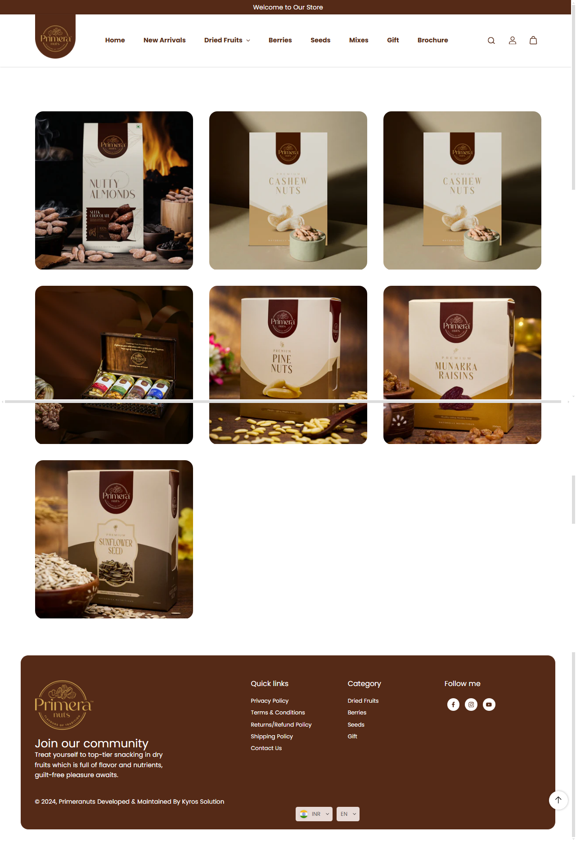

**3. Almonds Page :-**

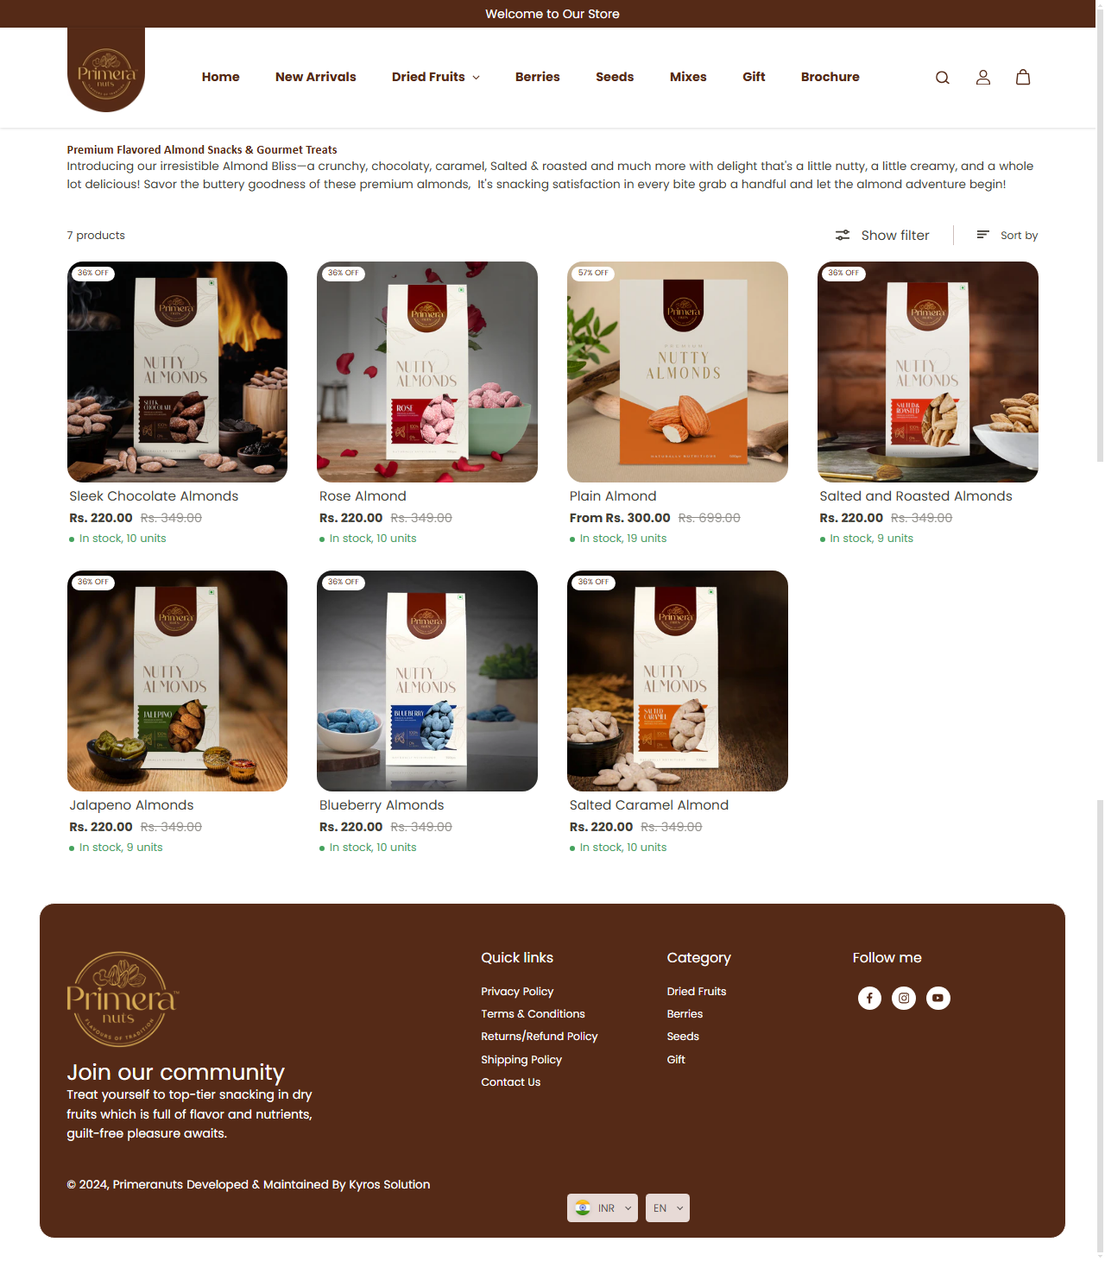

**4. Raisins Page**

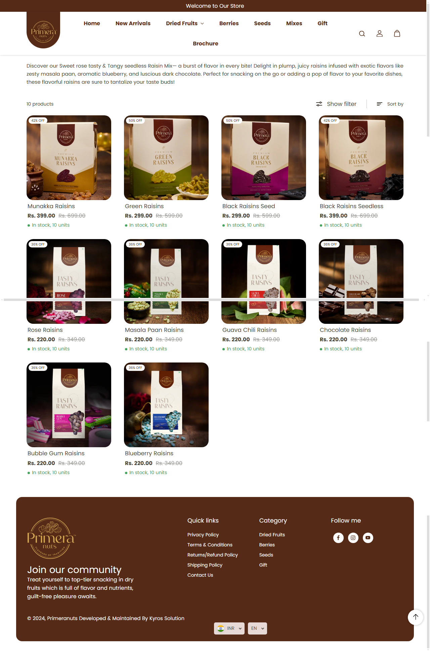

**5. Nuts page**

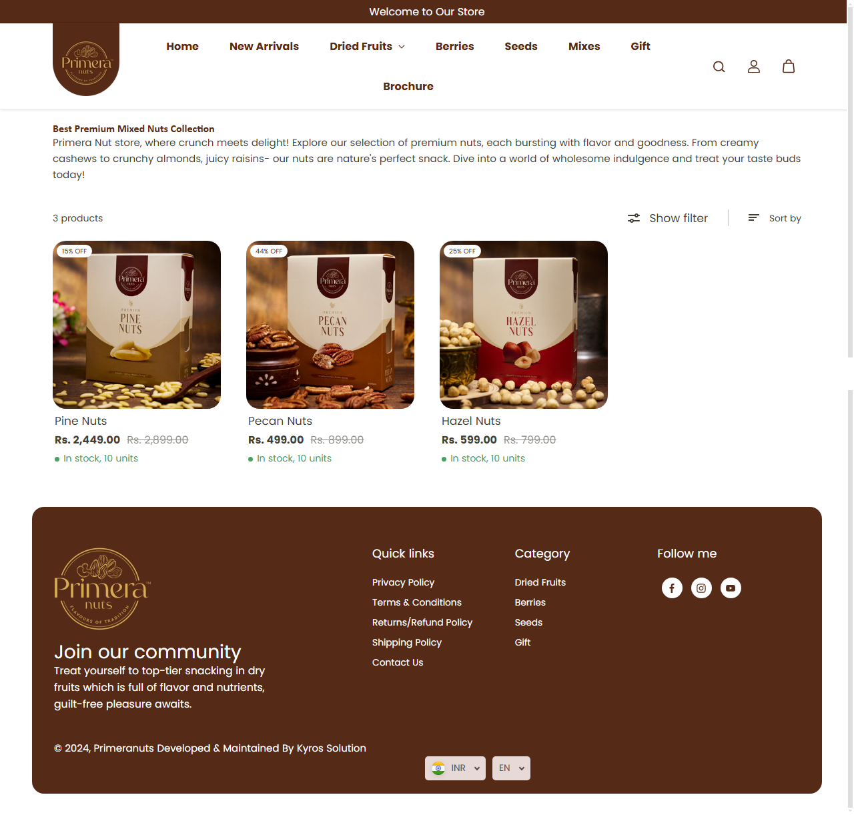

**6. Seeds Page**

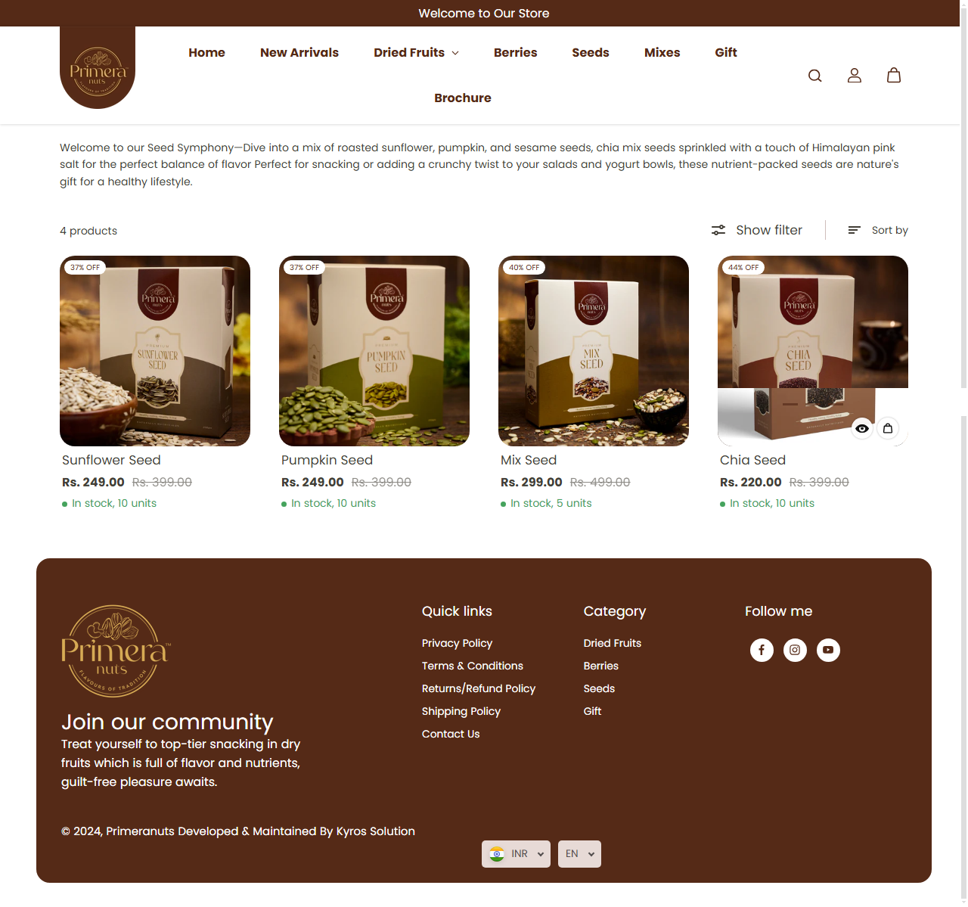

**7. Mixes Page**

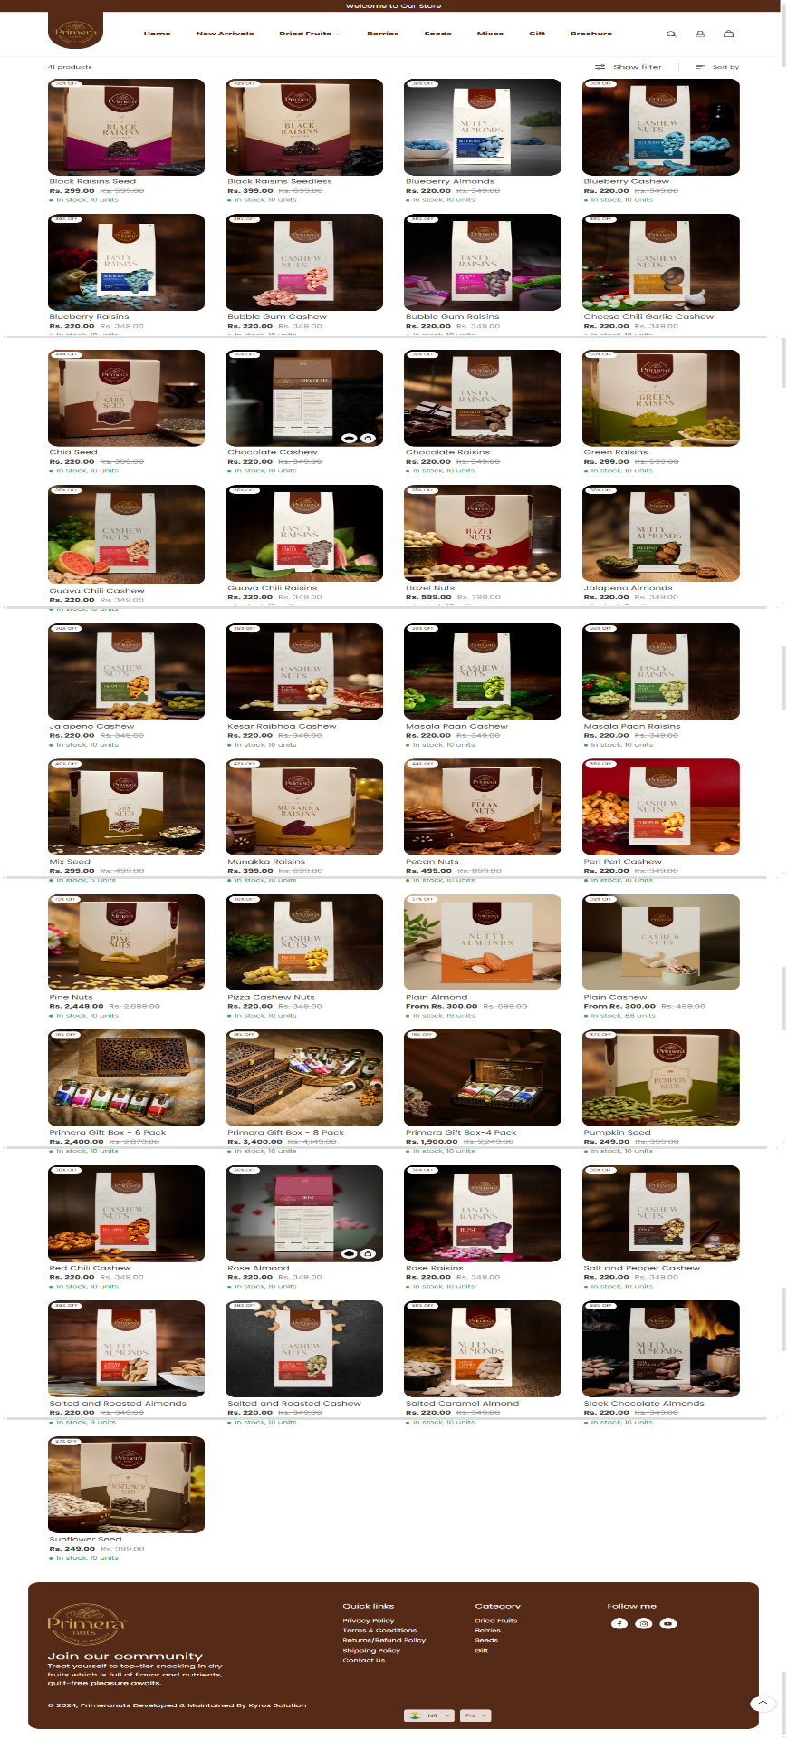

**8. Gift Page**

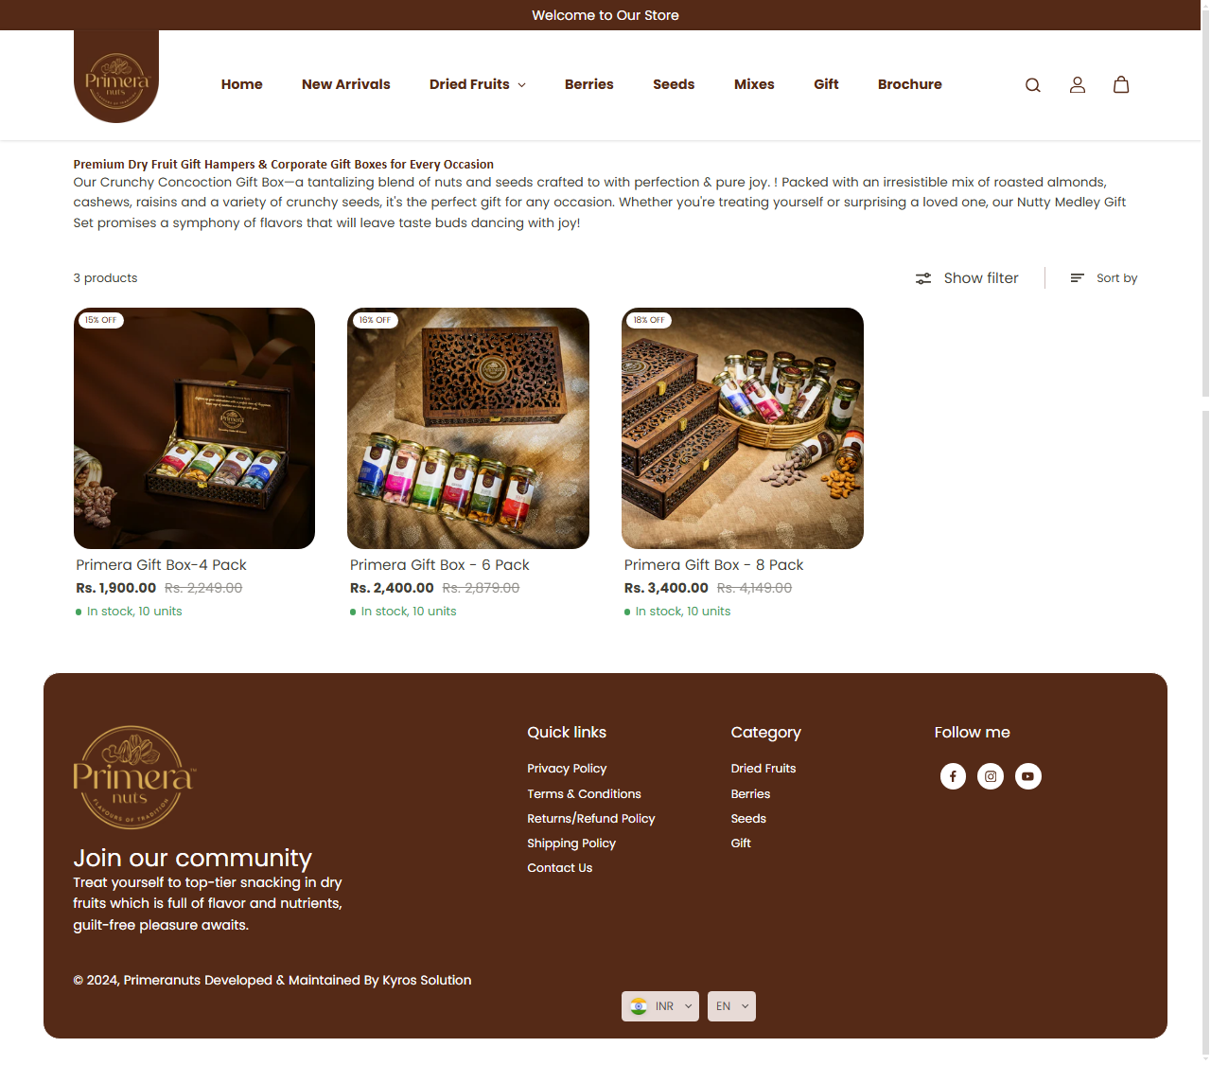

**9. Privacy Policy Page**

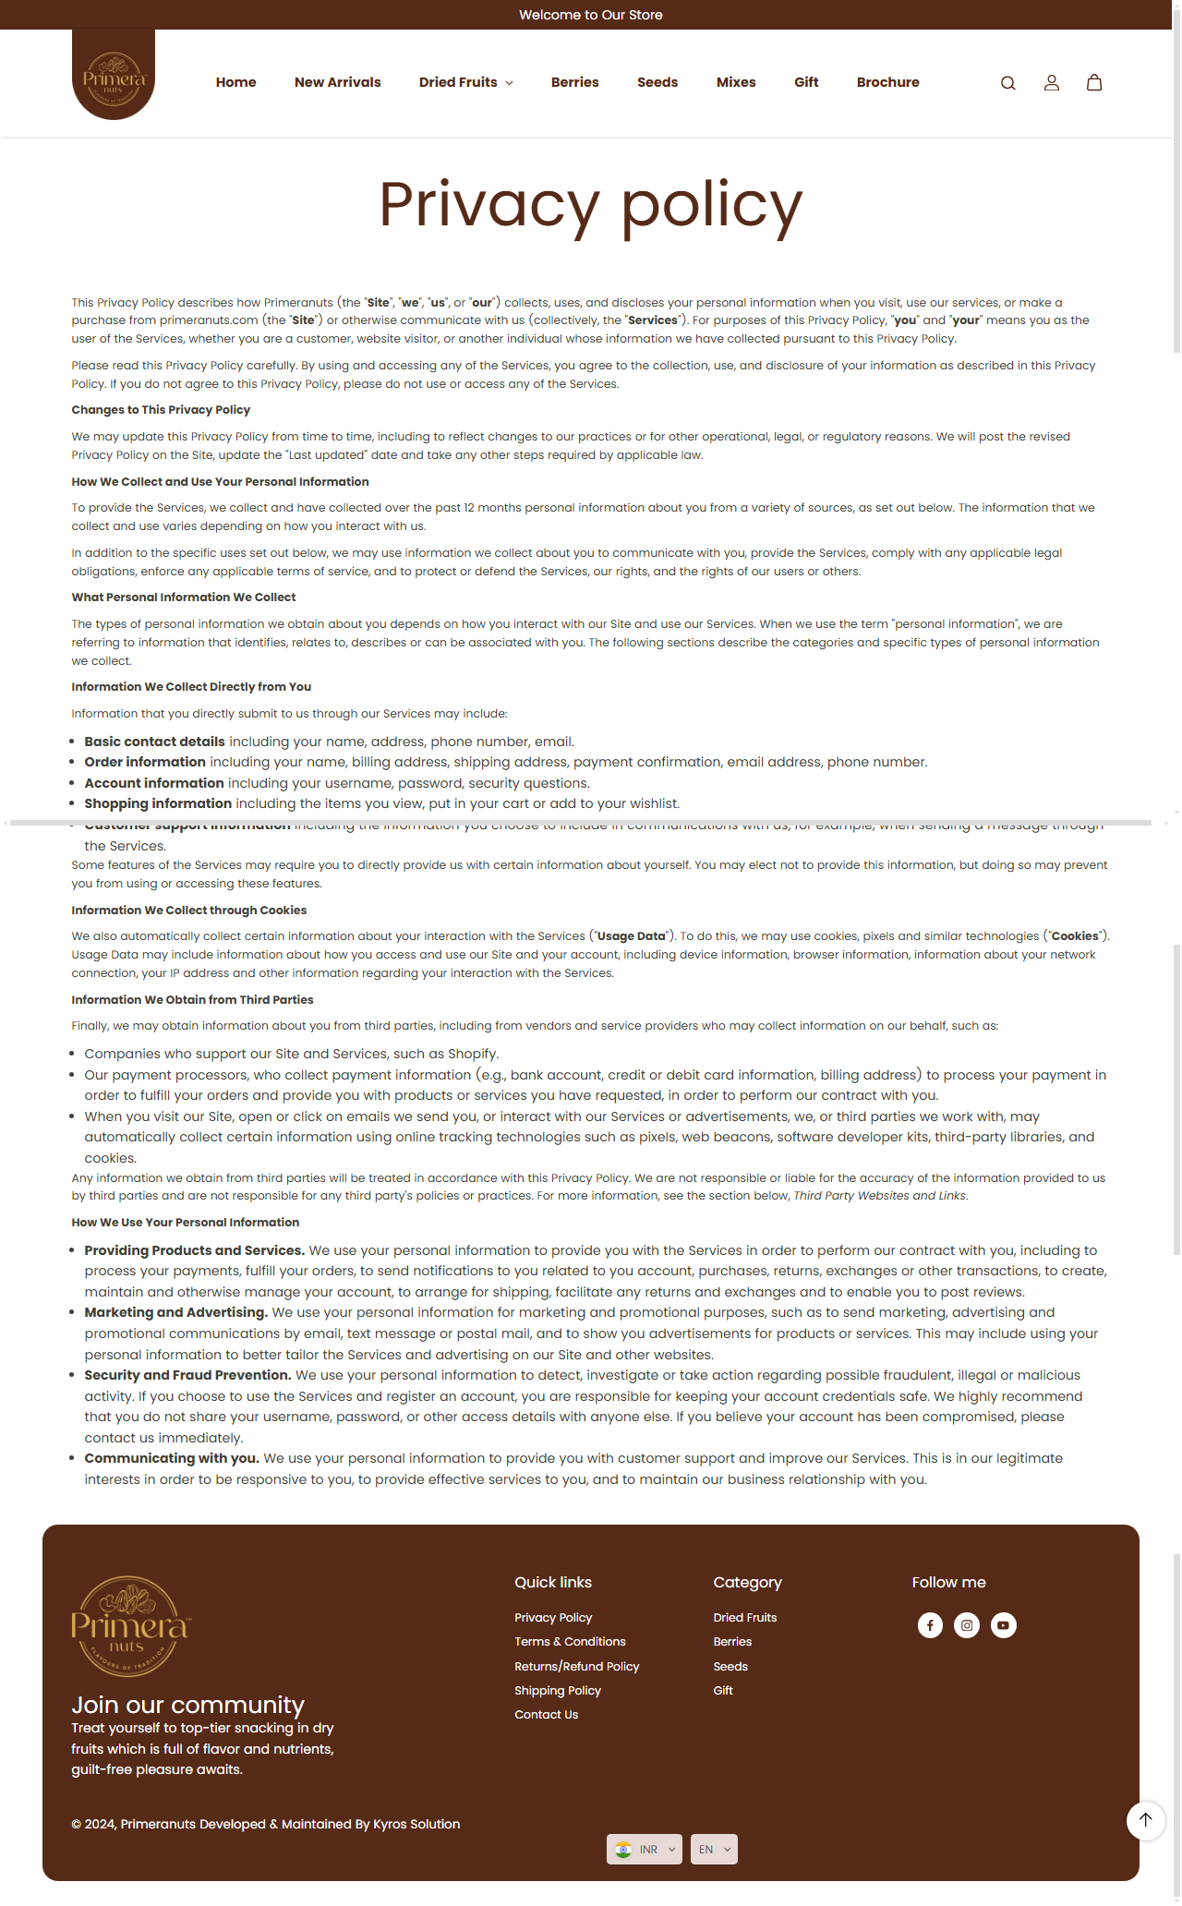

## **In Future Update**

To ensure Primera dry fruit website stays competitive, secure, and user-friendly, you can implement several future updates. Below is a list of suggested **front-end** and **back-end** updates that can enhance your website over time.

## **Reference From:**

* primera official website.

(https://primeranuts.com/)